Weak interactions among algae, mayflies, and tadpoles suggest communities respond weakly to mountain yellow-legged frog extinctions.

Thomas C. Smith†, Marina Bozinovic, Yishen Miao, Cheryl J. Briggs

Department of Ecology, Evolution, and Marine Biology, University of California, Santa Barbara, California 93106 USA; phone: (805) 893-2888

†email: thomas.smith@lifesci.ucsb.edu

Author Contributions: Thomas C. Smith conceived the study, performed the research and analysis, and wrote the manuscript; Marina Bozinovic and Yishen Miao contributed to the research, analysis, and text, and edited the manuscript; Cherie J. Briggs contributed to study design, data analysis, and edited the manuscript.

Abstract

Worldwide declines in amphibian populations and diversity have prompted investigations into the ecological roles of amphibian species and the consequences of their extinctions. In the Sierra Nevada of California, mountain yellow-legged frogs are nearly extinct, yet their impacts on, and responses to, other species remain largely unquantified. We performed two experiments to examine yellow-legged frog tadpole impacts on algal communities and the outcomes of competitive interactions between tadpoles and mayflies. Field experiments in two high mountain lakes showed that algal abundance declined with increasing mayfly, but not tadpole, density. Interspecific competition with mayflies and intraspecific competition had no effects on tadpole performance, but increasing tadpole abundance may have facilitated individual tadpole growth. Interspecific competition with tadpoles and intraspecific competition caused declines in individual mayfly size. I also performed a separate mesocosm experiment with no or high densities of tadpoles and mayflies. In this experiment, the presence of tadpoles reduced algal abundance by about 50%, but did not reduce algal growth rates. Mayflies also reduced algal abundance, but only in the presence of tadpoles. Overall, my studies indicate that23 the removal of mountain yellow-legged frog tadpoles allow benthic primary producers to reach higher abundance and may both harm and help other grazers. The effects of tadpole and mayfly grazers on their algal food resources and each other, however, were variable and appeared to depend on the environmental context.

Keywords: *Ameletus spp.,* amphibian declines, *Callibaetis ferrugineus*, interspecific competition, *Rana sierrae,* response surface design, Sierra Nevada lakes, grazing

Introduction

Although worldwide amphibian population declines and extinctions have been recognized for over 25 years (Stuart et al. 2004, Wake and Vredenburg 2008), the ecological consequences of most of these declines remain unquantified (but see Whiles et al. 2006, Connelly et al. 2008, Whiles et al. 2009, Colón-Gaud et al. 2009, Colón-Gaud et al. 2010a, Colón-Gaud et al. 2010b, Whiles et al. 2012, Connelly et al. 2014). Species extinctions can alter communities, in part through the loss of consumer effects on their resources (Hairston et al. 1960, Paine 1966, Carpenter et al. 1985, Chalcraft and Resetarits 2003, Gruner et al. 2008) or through competitive release (Holbrook and Schmitt 1995). Declines and extinctions of amphibians have the potential to change communities, but effects on resource bases and other consumers appear to be species-specific (Menge 2003).

The degree to which a species affects its community may depend on several factors, including the effects of the specific consumer species on its resources (Shurin et al. 2002, Borer et al. 2005, Wollrab et al. 2012) and on other species that share the same resources (Murdoch et al. 2003). Therefore, predictions about the ecological effects of declines or extinctions of a species should be based on quantitative measurements of its unique interactions with other community members (Simberloff 2003).

The effects of amphibian declines on freshwater and terrestrial communities likely depend on the ecological characteristics of the declining taxa. Although over 40% of the known 5700 amphibian species are declining in abundance, shrinking in distribution, or both (Stuart et al. 2004), declines in anurans (frogs and toads) driven by habitat destruction, over-exploitation, disease, and/ or their interactions are the most extensive and best understood (Stuart et al. 2004). Anurans, and especially their tadpoles, may play ecologically important roles (Alford 1999). Many tadpoles are grazers that reduce the abundance of benthic primary producers, by up to 98% in some cases (, Kupferberg 1997a, 1997b, Alford 1999, Connelly et al. 2008, 2014) with repercussions for the rest of the stream community, particularly other grazers (Brönmark et al. 1991, Kupferberg 1997a, 1997b). Tadpoles also can interfere with or facilitate the feeding of aquatic insects and other amphibians (Steinwascher 1978a, Kiffney and Richardson 2001, Ranvestel et al. 2004) and can be negatively affected by interspecific competition (Morin et al. 1988).

Tadpoles of the endangered mountain yellow-legged frogs (*Rana muscosa* and *R. sierrae*) graze on benthic algae and can affect other grazers, such as mayfly nymphs, caddisfly and fly larvae, and other benthic macroinvertebrates (Grinnell and Storer 1924, Zweifel 1955, Finlay and Vredenburg 2007). Because of their historical ubiquity and abundance, yellow-legged frog tadpoles may have been ecologically important components of Sierra Nevada aquatic ecosystems (Grinnell and Storer 1924. In lakes in the Sierra Nevada and in streams of the Transverse Ranges of southern California (Vredenburg et al. 2007), tadpoles once reached densities approaching 20-30 individuals per meter of lake shoreline (Roland A. Knapp, personal communication).

Mountain yellow-legged frog and tadpole populations initially declined due to predation by stocked non-native trout (Knapp and Matthews 2000). Even after trout stocking stopped, however, yellow-legged frog populations continued to decline owing to the emergence and spread of the amphibian chytrid fungus, *Batrachochytrium dendrobatidis* (Briggs et al. 2005). Today, large yellow-legged frog populations are limited to a handful of extremely high elevation lakes in Yosemite and Sequoia/Kings Canyon National Parks and the adjacent John Muir Wilderness in the southern Sierra. Mountain yellow-legged frogs and their tadpoles have gone locally extinct in most Sierran lakes (Briggs et al. 2010, Vredenburg et al. 2010).

To explore how declines and local extinctions of mountain yellow-legged frogs might affect Sierra Nevada lake communities, I examined the impacts of tadpoles on their resources and on potential competitors. Mountain yellow-legged frog tadpoles may reduce algal resources and compete, either through exploitative or interference interactions, with co-occurring native insect grazers. I chose to study interactions between yellow-legged frog tadpoles and mayfly nymphs because mayfly nymphs can suppress algal biomass and are abundant in Sierra Nevada lakes (, Bradford et al. 1998, , Hertonsson et al. 2007, Epanchin et al. 2009). I predicted that both mayflies and tadpoles would reduce algal abundance with reciprocal negative effects on each others’ growth and body size. To test these predictions, I performed two experiments which manipulated the presence or abundance of tadpoles and mayflies to examine their effects on algal abundance and/or competitor performance.

Methods

*Experimental methods*

I performed an *in situ* field experiment and an outdoor mesocosm experiment. In the field experiment, I examined interactions among mountain yellow-legged frog tadpoles (*Rana muscosa* and *Rana sierrae*), mayfly nymphs (Ephemeroptera: *Callibaetis ferrugineus* and *Ameletus edmundsi*), and their shared food resources (benthic organic matter: largely diatoms, but also green algae, cyanobacteria, chrysophytes, detritus, bacteria and other microbes, hereafter called “algae”) in two high-elevation lakes. In the subsequent mesocosm experiment, I measured the effects of two grazers (*Rana sierrae* tadpoles and *Callibaetis ferrugineus* nymphs) on algal resources in outdoor arenas with standard environmental conditions (temperature, nutrients, substrata).

*Field enclosure experiment. –* In the field enclosure experiment, I used a response surface design to characterize the independent and interactive effects of grazers on their algal food resources, as well as on themselves and each other (Inouye 2001). I set up a fully factorial design where four densities of tadpoles (0, 2, 10, and 20 individuals) were cross-classified by four densities of mayfly nymphs (0, 25, 125, and 250 individuals). The highest density treatments were set by the highest density of these consumers that my colleagues and I have observed in High Sierra lakes, with lower densities set at half and 1/10 of these maxima (Roland A. Knapp, personal communication, and T. Smith diss. 2015). I performed this experiment in two lakes and, within each lake at each time, each treatment was replicated once, with the exception that the no consumer control was replicated twice. Because of the remoteness of my study lakes, it was difficult to set up additional enclosures, so experimental treatments were replicated over three different times with new complements of grazers each time, producing 102 data points for the study (total number of data points = 17 enclosures/lake X 2 lakes X 3 times with each time treated as a block in analysis).

The two study lakes were remote high elevation lakes in the Kings Canyon National Park backcountry, which we refer to as LeConte (3221 m elevation, 37°06'58.78" N 118°38'40.16" W) and Spur Lakes (48 km to the southeast of LeConte, 3518 m elevation, 36°43'47.49" N 118°23'38.33" W, Google Earth 2014). These lakes are small alpine lakes lying just west of the Sierran crest, with LeConte Lake being surrounded by small meadows, white bark pine and willow forests, talus, and bare bedrock and Spur Lake being found in a basin devoid of vegetation, containing mostly talus and minimal bare bedrock. These lakes have low nutrient concentrations and circumneutral pHs: nitrate 0 – 10 μmol L-1, total phosphorus 0 – 1 μmol L-1 (Sickman et al. 2003); median pH ≅ 7 (Bradford et al. 1998). I selected these two lakes because both had large, disease-free cohorts of mountain yellow-legged frog tadpoles and large mayfly nymph populations, were relatively accessible, and were seldom visited by backpackers.

Seventeen enclosures were placed along each lake’s shoreline in the littoral zone where tadpoles feed during the day. Each enclosure was 0.5 m wide x 0.5 m tall at one end and 0.5 m wide x 1.5 m tall at the opposite end, and were 2 m long (bottom area = 1 m2). Each enclosure was oriented perpendicular to the shoreline, so that the tall end sat in deep water and the short end sat on the shoreline, allowing tadpoles to use deep and shallow water (Fig. 1). Enclosures were supported by light weight steel frames (Sturdy Stake #ST6 www.homedepot.com) and guy-lines, and made of synthetic nylon mesh fabric (pore size ca. 250 μm, Nitex SKU 24-C44, www.wildco.com). This mesh size enclosed mayflies and tadpoles while preventing the immigration of other benthic macroinvertebrates, but allowed the exchange of water, sediment, phytoplankton, and small zooplankton between the inside and outside of enclosures (mostly Copepoda).

The tadpoles I collected from, and used in experiments at, LeConte Lake belonged to the species *Rana sierrae*, whereas the tadpoles collected and used at Spur Lake were the ecologically similar *Rana muscosa* (Vredenburg et al. 2007). After weighing and staging tadpoles (Gosner 1960), I placed tadpoles between Gosner stages 26 and 39 into enclosures (UCSB IACUC protocol #6-08-762). When individual tadpoles reached stage 39, they were released into their home lake so they did not metamorphose within enclosures, and each released tadpole was replaced with a younger tadpole. On average, we replaced 1.3 (SE = 0.3) tadpoles per cage per time block (about 12% ± 3 (SE) of the tadpoles in each cage). I captured mayflies in lake littoral zones using benthic sweeps with a standard D-net (mesh size 250 μm), then separated mayflies without wing pads from other invertebrates in a sorting pan using forceps and a turkey baster. The mayflies in LeConte Lake were virtually all *Ameletus edmundsi*, but in Spur Lake, both *Ameletus edmundsi* and *Callibaetis ferrugineus* were present in similar proportions. Emerging adult mayflies during experiments were collected and replaced with younger individuals, with an average of 2 ± 0.4 mayflies being replaced per enclosure per block. Most mayfly emergence occurred during the first two time blocks (July and August) with almost none occurring during the last block (September).

I measured algal biomass as AFDM concentration on unglazed porcelain tiles placed on the bottom of each enclosure (two sets of 12 porcelain tiles, each 2.4 cm x 2.4 cm, 140 cm2 total area per enclosure). To account for potential within lake variation in algal growth not owing to variable grazing pressure, I placed a set of the same tiles in a small bag made of 250 m mesh next to each enclosure (Figure 1). I characterized the substratum under each enclosure as percent of substrata composed of silt (defined as particles < 0.5 mm, as in Knapp and Matthews 2000). Light intensity (photosynthetic photon flux) within each enclosure was measured at the water surface using a quantum meter (Apogee Instruments, Logan, UT).

Experiments began in the early ice-free season (17 July 2009 in LeConte and 21 July 2009 in Spur), and each of the three subsequent temporal blocks lasted 16-21 days. At the beginning of each time block, I weighed and staged all experimental tadpoles, and placed clean tiles and targeted numbers of tadpoles and mayfly nymphs in enclosures. At the end of each time block, I determined algal, mayfly nymph, emerged adult mayfly, and tadpole abundances, as well as tadpole stage and weight. I collected algal samples from tiles in enclosures and control mesh bags by scrubbing tiles with a soft-bristle toothbrush, suspending organic matter in 60 mL of water, then filtering algal suspensions through glass fiber filters (1.2 μm pore size). Filters were wrapped in foil, stored in a cool dark place in the field, then transported to and frozen in the laboratory. In the laboratory, filters were dried at 105o C for at least 24 hours, weighed, combusted at 500o C for 1 hour, and then re-weighed. Ash-free dry mass (AFDM) was calculated as the difference in filter-plus-sample weights before and after combustion (Hauer and Lamberti 2007).

At the end of each time block, I counted, weighed, and staged tadpoles. At the conclusion of the entire experiment, all tadpoles were weighed and staged a final time, then released back into their home lakes. I used a Gosner stage-mass regression equation, developed from a sample of 37 tadpoles collected from Marmot Lake, CA, to calculate the biomass of tadpoles at the beginning and end of time blocks (tadpole mg AFDM = 3 x 10-7 x stage5.3, R2 = 0.58).

At the end of each time block, I counted the number of mayfly nymphs in each enclosure, and collected and counted emerged adult mayflies. Mayfly nymphs collected after the last time block were preserved in 70% ethanol (n=928), then were measured to the nearest 0.1 mm at 10 x magnification, dried at 105o C for 24 hours, weighed, combusted at 500o C for 1 hour, and re-weighed, to obtain estimates of mayfly AFDM from the resulting length/mass regression (as for tadpole samples).

[Tom: The weakest parts of this experiment, which need to be addressed, are:

1. The artificiality of food and substrata conditions within enclosures. Algae should have been allowed to colonize and grow on tiles for some time before treatments were set up, and natural substrata should have been placed in enclosures. There are a couple of ways to address some of these problems. You could cite literature for studies which used nylon mesh (and a small number of tiles) as a substrate for algal colonization and growth. You could state that nylon mesh bottoms simulated smooth lake bottoms (not sure this is true). You could show that algal biomass in control enclosures and control mesh bags were relatively high and comparable to algal biomass measured on natural substrata (perhaps from the literature or you own measurements in other studies) to show that algal levels approached natural levels, at least by the end of the experiment.

2. Reuse of individual tadpoles and mayflies across different time blocks. This needs to be clarified, but it appears that you reused the same individual consumers in different time blocks, and it would have been much better if different individuals were used in different time blocks, so they can be viewed as independent replicates. If each enclosure contained mostly the same individuals among time blocks, then something like a repeated measures ANOVA would have been more appropriate.

3. Because you replaced tadpoles that reached a late Gosner stage and any mayflies that emerged, the interpretation of growth and size data become problematic, because different individual consumers will have been inside enclosures for different amounts of time, so would have been exposed to treatments for different amounts of time. The best way to deal with this problem is to show that only small proportions of the manipulated consumer populations were replaced over a time block. You did this to some degree for tadpoles, but not for mayflies. Also, the important parameter is not the average number replaced for each consumer species per enclosure, but the % of the consumer population at each consumer density level which was replaced for each time block and over the entire experiment. In lieu of this, you could maybe get at the growth rates or sizes of tadpoles or mayflies that were added at the beginning of the time period versus those that had remained from the last time period by looking at the size structure data. If tadpoles and mayflies that were added, to replace those that were lost to metamorphosis or emergence, were smaller than those that remained in enclosures, then you might expect a bimodal size distribution at the end of a time period. If so, then you can treat final size for each mode separately, so you would get size of added vs. remaining consumers, or, if you have initial sizes for each cohort, you could get growth rates for added vs. remaining consumers in each time period. Is this possible? Finally, because you know how many consumers were added to each enclosure at any point in time, as well as how many tadpoles metamorphosed or mayflies emerged, then you should also be able to calculate mortality rates for each consumer species for each time period, unless you had substantial numbers of escapees. Metamorphosis and emergence rates could also be better quantified to see if they are affected by treatment. If it is possible, then, you could partition population losses for tadpoles and mayflies into death (both), metamorphosis (tadpoles), and emergence (mayflies). Such vital rates are usually expressed in per capita terms (proportion of population) and have units of per day.]

*Mesocosm experiment. –* In the outdoor mesocosm experiment I used a 2 x 2 factorial design, where the presence and absence of tadpoles were cross-classified by the presence and absence of mayfly nymphs, with four replicate mesocosms assigned to each the four treatments (no consumers, 16 tadpoles, 250 mayfly nymphs, and 16 tadpoles + 250 mayfly nymphs). Mesocosms were located at the Sierra Nevada Aquatic Research Laboratory (SNARL) near Mammoth Lakes, CA (2165 m elevation, 37°36'50.83" N 118°49'57.56" W) and consisted of sixteen cube-shaped (1 m3) concrete tanks lined with Thoroseal concrete sealer, with sloping, partially submerged shelves on one side to allow tadpoles and metamorphs to bask (Fig.1). These tanks were filled with water from adjacent Convict Creek, which contained nitrate and phosphate levels similar to, but pHs which were higher than, those observed in other Sierra Nevada lakes (tank pH 7.9 – 8.5, Leland et al. 1989, Sickman et al. 2003). Tank pHs, however, were within the range observed for lakes containing high densities of mayfly nymphs and tadpoles (pH 6.5 - 8.5, Bradford et al. 1998). Mesocosms were filled in April 2010 and thirty sets of per set , tile in each tank = were placed in each mesocosm foring. Colonizing algae came from Convict Creek water and tile sets

I collected 160 *Rana sierrae* tadpoles (Gosner stages 34-39) from Marmot Lake (John Muir Wilderness, 3590 m elevation, 37°15'36.33" N 118°41'01.38" W) and transported them to SNARL in containers with portable aerators and cooled by blocks of snow. About 3000 mayflies (*Callibaetis ferrugineus*) were collected from a small pond in Yosemite National Park (2608 m elevation, 37°53'07.18" N 119°23'39.97" W) using a D-net with 250 μm mesh size; sorted using sieves, pipettes, and turkey basters; and transported to SNARL like the tadpoles.

The experiment began in late July 2010 when I added consumers to the mesocosms, then ran the experiment for 21 days. Mayfly nymphs disappeared from tanks over the course of the experiment. In contrast, tadpole abundance was maintained by adding young tadpoles to mesocosms to replace individuals which had metamorphosed and were removed. The experiment ended when tadpole densities could not be maintained because of high levels of tadpole metamorphosis. At the end of the experiment, I measured the size (tail muscle height and width, body length not including tail, and wet weight) and developmental stage (Gosner stage) of all tadpoles. During the experiment, mayfly nymphs were collected with the D-net, sampling until 20 consecutive sweeps collected no more mayfly nymphs. Mayflies were counted and measured as in the field enclosure experiment.

Algal abundance was determined four times during the experiment: once prior to experiment initiation in July, then at one (n = 15/mesocosm), two (n = 5 of tiles previously sampled), and three (all remaining tiles) weeks after the experiment started. Algae were removed from each tile by scrubbing and suspended in 60 mL of water, then algal suspensions were filtered through glass fiber filters. These samples were frozen immediately, and later processed for AFDM as described above.

[Tom: This experiment also suffers from a number of weaknesses:

1. The biggest problem, of course, was that treatments were not maintained. Given the disappearance of mayflies, you probably can’t say much about mayfly effects on algae or tadpoles. It might be good just to concentrate on tadpole effects on algae.

2. As with the previous experiment, it is difficult to interpret growth, biomass, or length data when consumers are replaced throughout the experiment or when population losses are so high. Also, many aquatic insects do not feed just before emergence. When consumer densities are declining owing to metamorphosis/emergence or death, then the analysis of grazing experiments is also problematic, because it is not clear what the average consumer density was or what the per capita grazing impact was. As for the previous experiment, you know the number of consumers added to each enclosure, so should be able to partition losses into death (for both), metamorphosis (for tadpoles), and emergence (for mayflies), so would have vital rate metrics for sources of loss. In both experiments, you need to show to what degree treatments were maintained by showing the population densities or levels of tadpoles and mayflies in each treatment over time.]

*Analytical methods*

I performed analyses to relate algal abundance to consumer abundance, and analyses to relate the body size of each consumer species to its abundance and the abundance of its competitor (Table 1).

*Analysis of field enclosure experiment. –* In the field enclosure experiment, I ran two analyses, with the first treating targeted mayfly and tadpole densities and the second using measured biomasses of mayflies and tadpoles at the end of each time block as continuous independent variables. Mayfly AFDM per enclosure was calculated as the product of the density of mayflies at the end of a time block and the associated mean individual mayfly AFDM estimated from the length-mass regression relationship. Tadpole AFDM per enclosure was calculated form the number of tadpoles and the average individual tadpole AFDM per enclosure at the end of each time block, the latter calculated from individual tadpole Gosner stages in each enclosure and the Gosner stage-mass relationship. In both analyses, I included categorical covariates for time block (three levels) and for lake ( two levels: LeConte and Spur). I also included duration of time block (days), solar radiation within enclosures, and substrata beneath enclosures as continuous covariates in these analyses.

Log-transformed algal biomass (as AFDM m-2) at the end of each time block for each enclosure was used as the response variable. I used linear mixed effects models (Zuur et al. 2009) to test the response of algal biomass to manipulated variation in consumer abundance and consumer biomass. Using a step-down model fitting procedure, we selected the best-fit model for the dataset based on Akaike Information Criteria (AIC) and visual inspection of model residuals (Zuur et al. 2009). Our initial models included the response variable algal abundance, the independent variables tadpole and mayfly abundance or biomass and their interaction effects, and covariates for underlying siltiness, light intensity, duration of time block, lake, and block number. I compared the performance of models that included random intercepts (for block and lake), random slopes for consumer effects in different lakes, and consideration of different variances among time blocks, lakes, and levels of mayfly and tadpole abundance (Zuur et al. 2009). To account for within-lake variation in algal biomass, we calculated a second response variable by subtracting algal biomass in each enclosure from algal biomass on control tiles in the nearby small bag which excluded grazers, then repeated analyses using this response variable.

To examine the effects of intraspecific and interspecific competition on mayfly size, I measured the lengths of just the mayflies used in the last time block. In this analysis, I used generalized least squares models with average mayfly length per enclosure as the response variable, tadpole and mayfly abundance as independent variables, and time block as a categorical covariate, including the lake by mayfly species interaction effect and considering differences in mayfly length variances across tadpole abundances and between mayfly species. Our model selection procedure was the same as described above.

To examine the potential effects of intraspecific or interspecific competition on tadpole body size, I used average tadpole AFDM per enclosure per time block as the response variable in linear models that included the independent variables tadpole and mayfly abundance, the categorical covariates lake and block, and a tadpole abundance by lake interaction effect. I included this interaction effect because preliminary plots suggested that the slopes of the relationships between tadpole biomass and abundance differed between lakes. Initial models allowed random intercepts and block differences in the variances of tadpole biomass. We tested for the normality of residuals of models of tadpole biomass by using a Shapiro-Wilk normality test and by graphically evaluated normality and heterogeneity of variances among levels of tadpole abundance, lake, and block. Our model selection procedure is described above.

*Analysis of mesocosm experiment. –* One of the key response variables in this experiment was algal growth rate, which was calculated as r (growth rate) = [ln (algal AFDM at time t)/(algal AFDM at beginning of experiment)]/time in days. The effects of treatment on algal growth were examined using generalized least squares models, similar to the procedures described above. The independent variables in these analyses were tadpole total biomass, the presence vs. absence of mayflies (because of widely varying densities over the course of the experiment), and their interaction effect, with allowances for different variances across consumer levels. Covariates included in initial models included the duration of algal growth (days) and log initial algal AFDM. I also repeated this analysis using final mayfly abundance rather than mayfly presence-absence as an independent variable. Analyses were performed and visualized using the nlme and ggplot2 packages in R (The R Foundation for Statistical Computing 2012).I also analyzed the responses of tadpole and mayfly lengths to competition. In these analyses, I used the mean lengths of tadpoles or mayflies in each mesocosm as response variables. The effects of heterospecific competitor presence on consumer length was evaluated using one-way analysis of variance (ANOVA) and, in addition, the effects of final mayfly AFDM and tadpole presence on mayfly length were examined using an ANCOVA.

Results

*Field enclosure experiment. –* Tadpoles and mayflies had negative but inconsistent effects on algal biomass in field enclosures, with grazer impacts being more pronounced in Le Conte than Spur Lakes (Figure 2). The best-fit model (Table 2) included a random intercept for time block and the fixed effects of lake, tadpole density, and mayfly density (Table 3). Repeating the analysis using measured consumer biomasses, rather than targeted densities, as independent variables produced essentially the same result. When we used the difference between algal biomass in enclosures and in adjacent mesh bags as the response variable, only mayfly density had a significant negative effect on algal biomass. Although there was no main effect of lake on this response variable, variation in this difference was an order of magnitude higher in Spur than LeConte Lake. The best fit linear mixed effects model of algal biomass controlled for within lake variation in algal growth (Table 4) included fixed effects for mayfly abundance and time block duration. The model also included a random intercept for time block, nested within lake, and allowed the variance of the response variable to differ among time blocks and between lakes (Table 5, Figure 4).

Average individual tadpole biomass increased with increasing tadpole abundance in LeConte Lake but remained relatively constant in Spur Lake, as reflected in the significant targeted tadpole density by lake interaction effect in the best fit statistical model (Fig. 5, Table 6, 7). The slope of the individual tadpole biomass vs. tadpole density relationship was +0.25 + 0.08 in LeConte Lake and -0.11 + 0.08 in Spur Lake. Targeted mayfly density had no effect on average individual tadpole biomass. In contrast, the average body length of mayfly nymphs tended to decline with increasing densities of both tadpoles and mayflies (Figure 6). *Ameletus edmundsi* length was reduced by 6-17% in the presence (vs. absence) of tadpoles in LeConte Lake, but tadpole presence had no effect on either *Ameletus* or *Callibaetis* lengths in Spur Lake. The average length of *A. edmundsi* was reduced by 8-23% from the lowest to highest mayfly densities in LeConte Lake and the average length of *C. ferrugineus* was reduced by 8-10% from the lowest to highest mayfly densities in Spur Lake. . Differences in mayfly length between LeConte and Spur Lakes may have been due to phenological differences between these lakes, because LeConte was lower and warmer than Spur Lake.

*Mesocosm experiment. –* In the 2010 mesocosm experiment, densities andimago ewere n, indicating that mayfly declines were owing to mortalityMayfly loss rates were not affected by the presence vs. absence of

Algal biomass was reduced by 50% in the presence vs. absence of tadpoles, but was unaffected by the presence of mayflies (Figure 7). The best-fit model explaining variation in log (algal AFDM) included fixed effects for tadpole presence (slope = -0.04 + 0.01), duration of algal growth (-0.05 + 0.02), and the initial AFDM of algae (+0.59 + 0.28), allowing variances in algal biomass to differ between tadpole treatments (Table 9). We found no difference in algal growth rates among consumer treatments (Figure 8, ANOVA, F3,28 = 0.0011, p < 1.0). When I used final mayfly density, rather than mayfly presence-absence, as an independent variable in analyses of log-transformed algal biomass, I obtained a significant interaction effect between mayfly density and the presence of tadpoles (*t*1,25 = 3.6, *p* = 0.002) with algal biomass declining with increasing mayfly density in the presence of tadpoles, but not in their absence (Figure 9). Mayfly presence had no effect on tadpole body length (ANOVA, *F*1,6 = 0.7, *p* = 0.4).

[Tom: Many of the design and analytical issues are addressed above.

You do need to show the densities over time for both mayflies and tadpoles in the different treatments applied in both the enclosure and mesocosm experiments. This allows the reader to assess the effectiveness of your treatments and profoundly affects their interpretation of the data.

There is no need to include the tables, with the possible exception of Table 1, which should be used as a summary, rather than introductory, table. The information in the tables can be succinctly subsumed into either the text or into figure legends. You just need to report best fit models, the important effects of independent variables and covariates, and the important contrasts between treatments.

Many of your initial statistical models are overcomplicated and the inclusion of some of the covariates is unjustified and unnecessary (e.g., siltiness in the enclosure experiment). Further, the Methods indicated that the major response variable in the mesocosm experiment was algal growth rate, yet most of the results reported were for log (algal biomass). If you used algal growth as your response metric, then there is no need to be concerned with algal growth duration or initial algal biomass.

In all figures, you need to specify the replicates used in calculating medians, boxes, whiskers, etc. Apparently, the replicates for the enclosure experiment are the enclosure X time block datapoints (i.e., 3 datapoints per enclosure), but the time blocks are not independent (each enclosure shares some of the same individual consumers over time). Similar considerations apply even moreso to the mesocosm experiment. The best way to deal with such designs is to use repeated measures techniques or profile analysis. Remember the statistics should be dictated by the design, so the enclosure experiment is set up as a gadient deisgn where independent variables are continuous, whereas the mesocosm experiment was set up as a a two-way factorial design and can easily be analyzed by a two-way ANOVA.

Given that you know the number of mayflies and tadpoles added to each enclosure or mesocosm and their metamorphosis (tadpoles) or emergence (mayflies) rates you should be able to calculate mortality rates for each consumer in each enclosure. This is assuming you have no or few escapees. Further, in examining effects of treatment on consumer size, it would be important to distinguish the size of consumers that were added at the beginning of a time period vs. those that remained in containers from the previous time period, if this is possible. Otherwise, you have to assume that the proportion of consumers replaced for each time period is a constant, which is unlikely and likely confounded by relationships among consumer growth and emergence/metamorphosis rates. In short, a detailed analysis of consumer size structure at the end of each time period might allow you to deal with the confounding influences of consumer replacement on your consumer size results.]

Discussion

Overall, the effects of mountain yellow-legged frog tadpoles on algal resources and mayfly competitors ranged from none to strong (see summary in Table 1). Mountain yellow-legged frog tadpoles reduced algal biomass by 50% in outdoor mesocosms; however, they had only marginal effects on algal biomass in field enclosures, with apparent differences in their grazing impacts between the two study lakes. Tadpoles also reduced the individual growth rates of mayfly nymphs, as evidenced by decreased mayfly lengths in the presence of tadpoles in the mesocosm experiment and at high tadpole densities in one lake in the field enclosure experiment (Table 1). Tadpoles also appeared to facilitate their own individual growth in some situations, because average individual tadpole biomass was higher at high than low tadpole densities in LeConte Lake. Because the effects of these endangered tadpoles on algae and other grazers were low to moderate and varied widely across systems, their declines and extinctions may have muted and variable impacts on Sierra Nevada alpine lake communities.

The mixed results of these experiments highlight the potential impacts of environmental variation on the detection of consumer and competitor impacts and on the strength of species interactions (Chesson 2000, Menge 2003). The impacts of grazers on algal abundance, and of tadpoles on mayfly growth, were much stronger in LeConte than Spur Lakes, perhaps because LeConte Lake was at a lower elevation, had a longer growing season, and was warmer than Spur Lake, with possible repercussions for lake productivity. Tadpole grazing impacts appeared to be much stronger in the mesocosm than enclosure experiment, perhaps because pre-treatment algal colonization and growth times were much greater in the mesocosm than enclosure experiment, allowing a greater range of algal biomass for evaluating grazer impacts. Finally, the mesocosms were much more homogeneous in environmental conditions than the lake enclosures, with high environmental variation both within and between lakes, so consumer effects on their resources could be more clearly discerned against limited environmental variability in the mesocosm experiment.

Many experiments have concluded that tadpole grazing can reduce algal resources (e.g. Brönmark et al. 1991, Kupferberg 1997a, Alford 1999), reflecting a broader literature showing that aquatic grazers generally reduce algal biomass or density. In a meta-analysis of freshwater grazing experiments, Feminella and Hawkins (1995) reported that algal biomass was reduced by ambient grazer densities in over 70% of experiments, with the largest grazer impacts found in long laboratory experiments and smaller grazer impacts observed in short or field experiments with variable conditions or high environmental heterogeneity. As an example, large stream-to-stream variability in environmental conditions (e.g., canopy cover and light levels) can mask the effects of tailed frog tadpoles on algal biomass in Pacific Northwest streams (Lamberti et al. 1992, Mallory and Richardson 2005). Similarly, I attribute some of the differences in tadpole effects on algal resources and competitor growth between mesocosm and field enclosure experiments to the high environmental variability across enclosures and lakes in the field experiment.

Another question deals with the extent to which the results of manipulative and natural field experiments can be extrapolated to infer the effects of tadpole extinctions on whole systems. The exclusion of tadpoles from Neotropical streams resulted in 111% to 200% increases in algal abundance (Ranvestel et al. 2004, Connelly et al. 2008) which was similar to a 2-6 fold increase in algal abundance in these streams after tadpoles had been driven extinct by the chytrid fungus (Connelly et al. 2008, 2014). The relatively strong effects of Neotropical frog tadpoles on their communities versus the relatively weak effects of mountain yellow-legged frog tadpoles and tailed frog tadpoles on their communities reinforces the view that the ecological effects of amphibian declines will vary with each threatened species and its ecological context (Menge 2003).

Although tadpole growth may depend on both their own densities and those of heterospecific competitors (Steinwascher 1978), this study indicated little effect of tadpoles or mayflies on tadpole growth, with some indication that tadpole growth may have been enhanced at high vs. low tadpole densities in one lake. Weak effects of tadpoles on their algal resources and own growth rates could be owing to the low digestibility and low tadpole assimilation rates for some algal species, (Peterson 1987; Furey et al. 2014). Enhanced tadpole growth at high tadpole densities could perhaps be attributed to tadpole ingestion of their own feces, which contain a mixture of organic particle types at different stages of digestion (Gromko et al. 1973, Steinwascher 1978a, 1978b).

Tadpoles also reduced mayfly growth, as indicated by decreases in mayfly size in the presence or at high densities of tadpoles (de Roos and Persson 2013). Although tadpoles had weak (enclosure) to moderate (mesocosm) negative effects on algal resources, it is not clear if tadpole effects on mayfly growth could be attributed to interference versus exploitative competition. Although the removal of tailed frog tadpoles had no impact on algal resources in Kifney and Richardson’s (2001) study, by, suggesting that interference effects may be importantFurther, tadpole effects on algal abundance and mayfly growth were much stronger in LeConte Lake than Spur Lake. In general, the loss of mountain yellow-legged frog tadpoles from Sierra Nevada lakes may result in increases in mayfly performance, but this effect appears to vary across lakes.

Interestingly, mayflies reduced algal biomass in the mesocosm experiment, but only where tadpoles were present. This result indicates that tadpoles modified environmental conditions or algal communities in such a way as to increase mayfly effects on algal resources. Tadpoles can remove the silt covering bottom substrata, increasing the access of stream invertebrates to algal resources (Ranvestel et al. 2004). In addition, tadpole excretion can create nutrient hotspots which increase the quality and quantity of algal resources for grazers (Seale 1980, Vanni et al. 2002Smith diss. 2015). Because tadpoles may be important prey for some predators (e.g., garter snakes, adult frogs, and Clark’s nutcrackers) ( Jennings et al. 1992, Matthews et al. 2002) and may have important bottom-up effects owing to nutrient excretion, they may affect entire lake, riparian, and upland ecosystems (Pilliod 2002). In addition, tadpoles and adult frogs host parasite and microbial communities, which would be lost when frogs go extinct (Jani and Briggs 2014; Lafferty and Kuris 2009). Although my results indicate that frog extinctions would have limited effects on lake benthic algal biomass and invertebrate communities, other aspects of their roles in food web networks demand additional exploration.

[Tom:

I think that you misinterpreted some of your results, so I have rewritten the Discussion to reflect what I think the results actually say. I am happy to discuss with you anything you disagree with.

Also, you might want to include paragraphs on mayfly effects on tadpoles and on the asymmetry in the effects of mayflies and tadpoles on each other. Why do tadpoles have a large effect on mayfly growth, but mayflies have little or no effect on tadpole growth?]

Acknowledgements

The use of tadpoles in these experiments was approved by the University of California, Santa Barbara Institutional Animal Care and Use Committee (protocol #??). Administrators at Sequoia-Kings Canyon (SKCNP) and Yosemite National Parks permitted the research (?????) and I thank Danny Boiano from SKCNP for providing field logistical support. I thank Dan Dawson, Roland Knapp, and the staff at the Sierra Nevada Aquatic Research Laboratory for providing research and housing facilities and for logistical support. This research was supported by the National Science Foundation’s Ecology and Evolution of Infectious Disease program (EF-0723563), a University of California Natural Reserve System Mildred E. Mathias Grant for Graduate Student Research, a Henry Luce Foundation Environmental Science to Solutions Fellowship, and the UCSB Department of Ecology, Evolution, and Marine Biology. I thank Stephen DeLisle, Michael McFarlin, Garrison Loope, Michael Hernandez, Madelynn Johnston, Cord Dorcey, Andrea Jani, Mary Toothman, and Tate Tunstall for their assistance in the field and laboratory, and Nikki Gantos, Patricia Monie, and Dominique Monie for assistance in constructing the enclosures. Sally Holbrook and Scott Cooper provided valuable comments that enhanced the research and the manuscript.

Literature Cited [Insure that reference format is consistent.]

Alford, R. A. 1999. Ecology: resource use, competition, and predation. In Tadpoles: The Biology of Anuran Larvae:240–278.

Altig, R., and W. McDearman. 1975. PERCENT ASSIMILATION AND CLEARANCE TIMES OF 5 ANURAN TADPOLES. Herpetologica 31:67–69.

Arno, S. F., and R. J. Hoff. 1989. Silvics of whitebark pine (*Pinus albicaulis*). United States Department of Agriculture, Forest Service General Te.

Borer, E. T., E. W. Seabloom, J. B. Shurin, K. E. Anderson, C. A. Blanchette, B. Broitman, S. D. Cooper, and B. S. Halpern. 2005. What determines the strength of a trophic cascade? Ecology 86:528–537.

Bradford, D. F., S. D. Cooper, T. M. Jenkins Jr, K. Kratz, O. Sarnelle, and A. D. Brown. 1998. Influences of natural acidity and introduced fish on faunal assemblages in California alpine lakes. Canadian Journal of Fisheries and Aquatic Sciences 55:2478–2491.

Briggs, C. J., R. A. Knapp, and V. T. Vredenburg. 2010. Enzootic and epizootic dynamics of the chytrid fungal pathogen of amphibians. Proceedings of the National Academy of Sciences 107:9695 –9700.

Briggs, C. J., V. T. Vredenburg, R. A. Knapp, and L. J. Rachowicz. 2005. Investigating the population-level effects of chytridiomycosis: An emerging infectious disease of amphibians. Ecology 86:3149–3159.

Brönmark, C., S. D. Rundle, and A. Erlandsson. 1991. Interactions between freshwater snails and tadpoles: competition and facilitation. Oecologia 87:8–18.

Bruno, J. F., J. J. Stachowicz, and M. D. Bertness. 2003. Inclusion of facilitation into ecological theory. Trends in Ecology & Evolution 18:119–125.

Carpenter, S. R., J. F. Kitchell, and J. R. Hodgson. 1985. Cascading trophic interactions and lake productivity. Bioscience 35:634–639.

Chalcraft, D. R., and W. J. Resetarits. 2003. Predator identity and ecological impacts: functional redundancy or fuctional diversity? Ecology 84:2407–2418.

Chesson, P. 2000. Mechanisms of maintenance of species diversity. Annual Review of Ecology and Systematics:343–366.

Connelly, S., C. M. Pringle, T. Barnum, M. Hunte-Brown, S. Kilham, M. R. Whiles, K. R. Lips, C. Colón-Gaud, and R. Brenes. 2014. Initial versus longer-term effects of tadpole declines on algae in a Neotropical stream. Freshwater Biology 59:1113–1122.

Connelly, S., C. M. Pringle, R. J. Bixby, R. Brenes, M. R. Whiles, K. R. Lips, S. Kilham, and A. D. Huryn. 2008. Changes in Stream Primary Producer Communities Resulting from Large-Scale Catastrophic Amphibian Declines: Can Small-Scale Experiments Predict Effects of Tadpole Loss? Ecosystems 11:1262–1276.

Dudley, T. L. 1992. Beneficial effects of herbivores on stream macroalgae via epiphyte removal. Oikos 65:121–127.

Duellman, W. E., and L. Trueb. 1994. Biology of amphibians. Johns Hopkins Univ Pr.

Ellison, A. M., M. S. Bank, B. D. Clinton, E. A. Colburn, K. Elliott, C. R. Ford, D. R. Foster, B. D. Kloeppel, J. D. Knoepp, G. M. Lovett, J. Mohan, D. A. Orwig, N. L. Rodenhouse, W. V. Sobczak, K. A. Stinson, J. K. Stone, C. M. Swan, J. Thompson, B. Von Holle, and J. R. Webster. 2005. Loss of foundation species: consequences for the structure and dynamics of forested ecosystems. Frontiers in Ecology and the Environment 3:479–486.

Epanchin, P., R. Knapp, and S. Lawler. 2009. Nonnative trout impact an alpine-nesting bird by altering aquatic insect subsidies. Ecology.

Finlay, J. C., and V. T. Vredenburg. 2007. Introduced trout sever trophic connections in watersheds: Consequences for a declining amphibian. Ecology 88:2187–2198.

Furey, P. C., S. J. Kupferberg, and A. J. Lind. 2014. The perils of unpalatable periphyton: *Didymosphenia* and other mucilaginous stalked diatoms as food for tadpoles. Diatom Research 29:267–280.

Google Earth. 2014. ThomasCSmith_LeConteSpur_map.kmz. https://github.com/TomCSmith/manuscript-support-files/blob/master/ThomasCSmith_LeConteSpur_map.kmz.

Gosner, K. L. 1960. A simplified table for staging anuran embryos and larvae with notes on identification. Herpetologica 16:183–190.

Grinnell, J., and T. I. Storer. 1924. Animal Life in the Yosemite: An Account of the Mammals, Birds, Reptiles, and Amphibians in a Cross-section of the Sierra Nevada. University of California Press.

Gromko, M. H., F. S. Mason, and S. J. Smith-Gill. 1973. Analysis of the crowding effect in *Rana pipiens* tadpoles. Journal of Experimental Zoology 186:63–71.

Gruner, D. S., J. E. Smith, E. W. Seabloom, S. A. Sandin, J. T. Ngai, H. Hillebrand, W. S. Harpole, J. J. Elser, E. E. Cleland, M. E. S. Bracken, E. T. Borer, and B. M. Bolker. 2008. A cross-system synthesis of consumer and nutrient resource control on producer biomass. Ecology Letters 11:740–755.

Hairston, N. G., F. E. Smith, and L. B. Slobodkin. 1960. Community Structure, Population Control, and Competition. The American Naturalist 94:421.

Hauer, F. R., and G. A. Lamberti. 2007. Methods in stream ecology. Academic Press.

Hertonsson, P., K. Åbjörnsson, and C. Brönmark. 2007. Competition and facilitation within and between a snail and a mayfly larva and the effect on the grazing process. Aquatic Ecology 42:669–677.

Hill, W. R., and A. W. Knight. 1987. Experimental analysis of the grazing interaction between a mayfly and stream algae. Ecology 68:1955–1965.

Holbrook, S. J., and R. J. Schmitt. 1995. Compensation in resource use by foragers released from interspecific competition. Journal of Experimental Marine Biology and Ecology 185:219–233.

Inouye, B. D. 2001. Response surface experimental designs for investigating interspecific competition. Ecology 82:2696–2706.

Jani, A. J., and C. J. Briggs. 2014. The pathogen *Batrachochytrium dendrobatidis* disturbs the frog skin microbiome during a natural epidemic and experimental infection. Proceedings of the National Academy of Sciences:1412752111–.

Jennings, W. B., D. F. Bradford, and D. F. Johnson. 1992. Dependence of the garter snake *Thamnophis elegans* on amphibians in the Sierra Nevada of California. Journal of Herpetology 26:503–505.

Kiffney, P. M., and J. S. Richardson. 2001. Interactions among Nutrients, Periphyton, and Invertebrate and Vertebrate (*Ascaphus truei*) Grazers in Experimental Channels. Copeia 2001:422–429.

Knapp, R. A., and K. R. Matthews. 2000. Non-native fish introductions and the decline of the mountain yellow-legged frog from within protected areas. Conservation Biology 14:428–438.

Kupferberg, S. 1997a. Facilitation of periphyton production by tadpole grazing: functional differences between species. Freshwater Biology 37:427–439.

Kupferberg, S. J. 1997b. The Role of Larval Diet in Anuran Metamorphosis 1. Integrative and Comparative Biology 37:146–159.

Kupferberg, S. J., J. C. Marks, and M. E. Power. 1994. Effects of variation in natural algal and detrital diets on larval anuran (*Hyla regilla*) life-history traits. Copeia 1994:446–457.

Lafferty, K. D., and A. M. Kuris. 2009. Parasites reduce food web robustness because they are sensitive to secondary extinction as illustrated by an invasive estuarine snail. Philosophical Transactions of the Royal Society B: Biological Sciences 364:1659–1663.

Lamberti, G. A., S. V. Gregory, C. P. Hawkins, R. C. Wildman, L. R. Ashkenas, and D. M. DeNicola. 1992. Plant—herbivore interactions in streams near Mount St Helens. Freshwater Biology 27:237–247.

Leland, H. V., S. V. Fend, T. L. Dudley, and J. L. Carter. 1989. Effects of copper on species composition of benthic insects in a Sierra Nevada, California, stream. Freshwater Biology 21:163–179.

Mallory, M. A., and J. S. Richardson. 2005. Complex interactions of light, nutrients and consumer density in a stream periphyton–grazer (tailed frog tadpoles) system. Journal of Animal Ecology 74:1020–1028.

Matthews, K. R., R. A. Knapp, and K. L. Pope. 2002. Garter snake distributions in high-elevation aquatic ecosystems: Is there a link with declining amphibian populations and nonnative trout introductions? Journal of Herpetology 36:16–22.

Menge, B. A. 2003. The overriding importance of environmental context in determining the outcome of species-deletion experiments. Pages 16–43 *in* P. M. Kareiva and S. A. Levin, editors. The importance of species: perspectives on expendability and triage. Princeton University Press.

Morin, P. J., S. P. Lawler, and E. A. Johnson. 1988. Competition between aquatic insects and vertebrates: interaction strength and higher order interactions. Ecology 69:1401–1409.

Murdoch, W. W., C. J. Briggs, and R. M. Nisbet. 2003. Consumer-resource Dynamics. Princeton University Press.

Paine, R. T. 1966. Food web complexity and species diversity. The American Naturalist 100:65.

Peterson, C. G. 1987. Gut passage and insect grazer selectivity of lotic diatoms. Freshwater Biology 18:455–460.

Pilliod, D. S. 2002. Clark’s Nutcracker (*Nucifraga columbiana*) Predation on Tadpoles of the Columbia Spotted Frog (*Rana luteiventris*). Northwestern Naturalist 83:59–61.

Power, M. E. 1992. Top-down and bottom-up forces in food webs: do plants have primacy. Ecology:733–746.

Ranvestel, A. W., K. R. Lips, C. M. Pringle, M. R. Whiles, and R. J. Bixby. 2004. Neotropical tadpoles influence stream benthos: evidence for the ecological consequences of decline in amphibian populations. Freshwater Biology 49:274–285.

Roos, A. M. de, and L. Persson. 2013. Population and Community Ecology of Ontogenetic Development. Page 552???. Princeton University Press.

Schmitt, R. J., and S. J. Holbrook. 1990. Population Responses of Surfperch Released from Competition. Ecology 71:1653–1665.

Seale, D. B. 1980. Influence of Amphibian Larvae on Primary Production, Nutrient Flux, and Competition in a Pond Ecosystem. Ecology 61:1531–1550.

Shurin, J. B., E. T. Borer, E. W. Seabloom, K. Anderson, C. A. Blanchette, B. Broitman, S. D. Cooper, and B. S. Halpern. 2002. A cross-ecosystem comparison of the strength of trophic cascades. Ecology Letters 5:785–791.

Sickman, J. O., J. M. Melack, and D. W. Clow. 2003. Evidence for nutrient enrichment of high-elevation lakes in the Sierra Nevada, California. Limnology and Oceanography 48:1885–1892.

Simberloff, D. 2003. Community and ecosystem impacts of single-species extinctions. Pages 221–234 *in* P. M. Kareiva and S. A. Levin, editors. The importance of species: perspectives on expendability and triage. Princeton University Press.

Steinwascher, K. 1978a. Interference and exploitation competition among tadpoles of *Rana utricularia*. Ecology 59:1039–1046.

Steinwascher, K. 1978b. The effect of coprophagy on the growth of *Rana catesbeiana* tadpoles. http://www.jstor.org.proxy.library.ucsb.edu:2048/stable/1443833.

Stuart, S. N., J. S. Chanson, N. A. Cox, B. E. Young, A. S. L. Rodrigues, D. L. Fischman, and R. W. Waller. 2004. Status and trends of amphibian declines and extinctions worldwide. Science 306.

The R Foundation for Statistical Computing. 2012. R: A Language and Environment for Statistical Computing. R Foundation for Statistical Computing, Vienna, Austria.

Vanni, M. J., A. S. Flecker, J. M. Hood, and J. L. Headworth. 2002. Stoichiometry of nutrient recycling by vertebrates in a tropical stream: linking species identity and ecosystem processes. Ecology Letters 5:285–293.

Vredenburg, V. T., R. Bingham, R. Knapp, J. A. T. Morgan, C. Moritz, and D. Wake. 2007. Concordant molecular and phenotypic data delineate new taxonomy and conservation priorities for the endangered mountain yellow-legged frog. Journal of Zoology 271:361–374.

Vredenburg, V. T., R. A. Knapp, T. S. Tunstall, and C. J. Briggs. 2010. Dynamics of an emerging disease drive large-scale amphibian population extinctions. Proceedings of the National Academy of Sciences 107:9689 –9694.

Wake, D. B., and V. T. Vredenburg. 2008. Are we in the midst of the sixth mass extinction? A view from the world of amphibians. Proceedings of the National Academy of Sciences 105:11466.

Wollrab, S., S. Diehl, and A. M. De Roos. 2012. Simple rules describe bottom-up and top-down control in food webs with alternative energy pathways. Ecology Letters 15:935–46.

Zuur, A. F., E. N. Ieno, N. J. Walker, A. A. Saveliev, and G. M. Smith. 2009. Mixed effects models and extensions in ecology with R. Springer.

Zweifel, R. G. 1955. Ecology, distribution, and systematics of frogs of the *Rana boylei* group. University of California Press.

Tables

|  |  |  |
| --- | --- | --- |
| Response | Result | Location |
| (F) Algal biomass vs. targeted grazer density | Tadpole abundance marginally reduced algal abundance; mayfly abundance had no significant effect | Table 2,3; Fig. 2, 3 |
| (F) Algal biomass vs. measured grazer biomass | Tadpole biomass marginally reduced algal abundance; mayfly biomass had no effect |  |
| (F) Algal biomass corrected for within-lake variation in algal growth vs. consumer density | Mayfly abundance reduced algal abundance; duration of experiment had a positive effect. Tadpole abundance has no effect. | Table 4, 5; Fig. 4 |
| (M) Algal biomass vs. grazer presence | Tadpoles reduced algal abundance about 50%; mayfly presence had no effect | Table 9, Fig. 7 |
| (M) Algal biomass vs. tadpole presence-absence and mayfly end density | Mayflies reduced algal abundance, but only when tadpoles were present | Table 10, Fig. 9 |
| (M) Algal growth rate vs. grazer presence | Algal growth rates did not differ among grazer treatments | Fig. 8 |
| (F) Mayfly length vs. tadpole and mayfly density | Both tadpole and mayfly abundance reduced mayfly body length. | Table 8, Fig. 6 |
| (M) Mayfly length vs. tadpole presence | Tadpole presence reduced mayfly length | Table 11, Fig. 10 (not included yet 11/24) |
| (F) Individual tadpole biomass vs. grazer density | Tadpole abundance increased tadpole biomass, but only in one lake. Mayflies had no effect. | Table 6, 7, Fig. 5 |
| (M) Individual tadpole biomass vs. mayfly presence | No effect of mayfly presence on tadpole biomass |  |

Table 1. Summary of response variables analyzed, results, and location in manuscript. The relevant experiment is indicated with the letter (F) field enclosure experiment in lakes in Kings Canyon National Park or (M) mesocosm experiment at the Sierra Nevada Aquatic Research Laboratory.







Table 3. Note block and lake effects in text and note magnitude of difference between lakes in text. List model coefficients, t, and p values in text or a figure legend.

|  |  |  |  |
| --- | --- | --- | --- |
|  |  |  |  |
|  |  |  |  |
|  |  |  |  |
|  |  |  |  |
|  |  |  |  |
|  |  |  |  |

Table 4. Just describe best fit model in text.

|  |  |  |  |  |  |
| --- | --- | --- | --- | --- | --- |
|  |  |  |  |  |  |
|  |  |  |  |  |  |
|  |  |  |  |  |  |
|  |  |  |  |  |  |
|  |  |  |  |  |  |

Table 5. Note direction of lake and block effects and model coefficients and associated t and p values in text or appropriate figure legend.

|  |  |  |  |  |  |
| --- | --- | --- | --- | --- | --- |
|  |  |  |  |  |  |
|  |  |  |  |  |  |
|  |  |  |  |  |  |
|  |  |  |  |  |  |
|  |  |  |  |  |  |

Table 6. Note direction of block effects and model coefficients and associated t and p values in text or appropriate figure legend.

|  |  |  |  |  |  |  |
| --- | --- | --- | --- | --- | --- | --- |
|  |  |  |  |  |  |  |
|  |  |  |  |  |  |  |
|  |  |  |  |  |  |  |
|  |  |  |  |  |  |  |
|  |  |  |  |  |  |  |

Table 7. Just note coefficents and associated t and p values for each lake separately in the text or an appropriate figure legend.

|  |  |  |  |  |
| --- | --- | --- | --- | --- |
|  |  |  |  |  |
|  |  |  |  |  |
|  |  |  |  |  |
|  |  |  |  |  |
|  |  |  |  |  |
|  |  |  |  |  |

Table 8. Primarily just need to note tadpole abundance, lake, and mayfly X lake effects (coefficients, t and p values) in text or appropriate figure legend.

|  |  |  |  |  |
| --- | --- | --- | --- | --- |
|  |  |  |  |  |
|  |  |  |  |  |
|  |  |  |  |  |
|  |  |  |  |  |

Table 9. Why not use algal growth rates instead. If you go with log(algal biomass), then just report coefficients (and t and p values) in text or an appropriate figure legend.

|  |  |  |  |  |
| --- | --- | --- | --- | --- |
|  |  |  |  |  |
|  |  |  |  |  |
|  |  |  |  |  |
|  |  |  |  |  |
|  |  |  |  |  |
|  |  |  |  |  |

Table 10. Just need to report coefficients and associate t and p values for initial algal biomass, algal growth duration, and tadpole X mayfly interaction effect in text or appropriate figure legend.

Figures

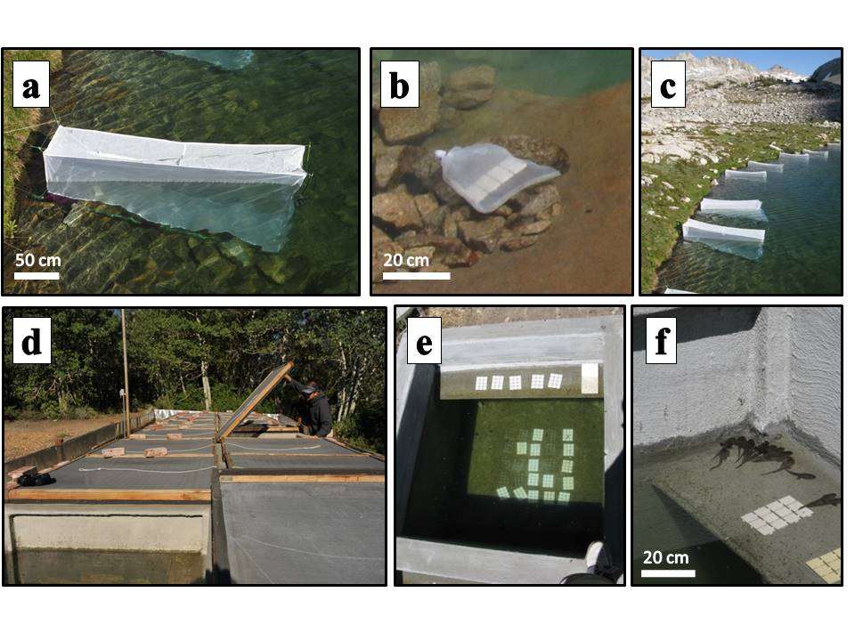

FIG. 1. a) *in situ* experimental enclosure in LeConte Lake, b) control tiles in bag of same mesh as the enclosures and placed next to each enclosure, c) field enclosures in LeConte lake in Kings Canyon National Park, d) mesocosms located at the Sierra Nevada Aquatic Research Laboratory near Mammoth Lakes, CA, e) view of experimental tiles in one mesocosm, and f) tadpoles basking on the shelf in one of the mesocosms.

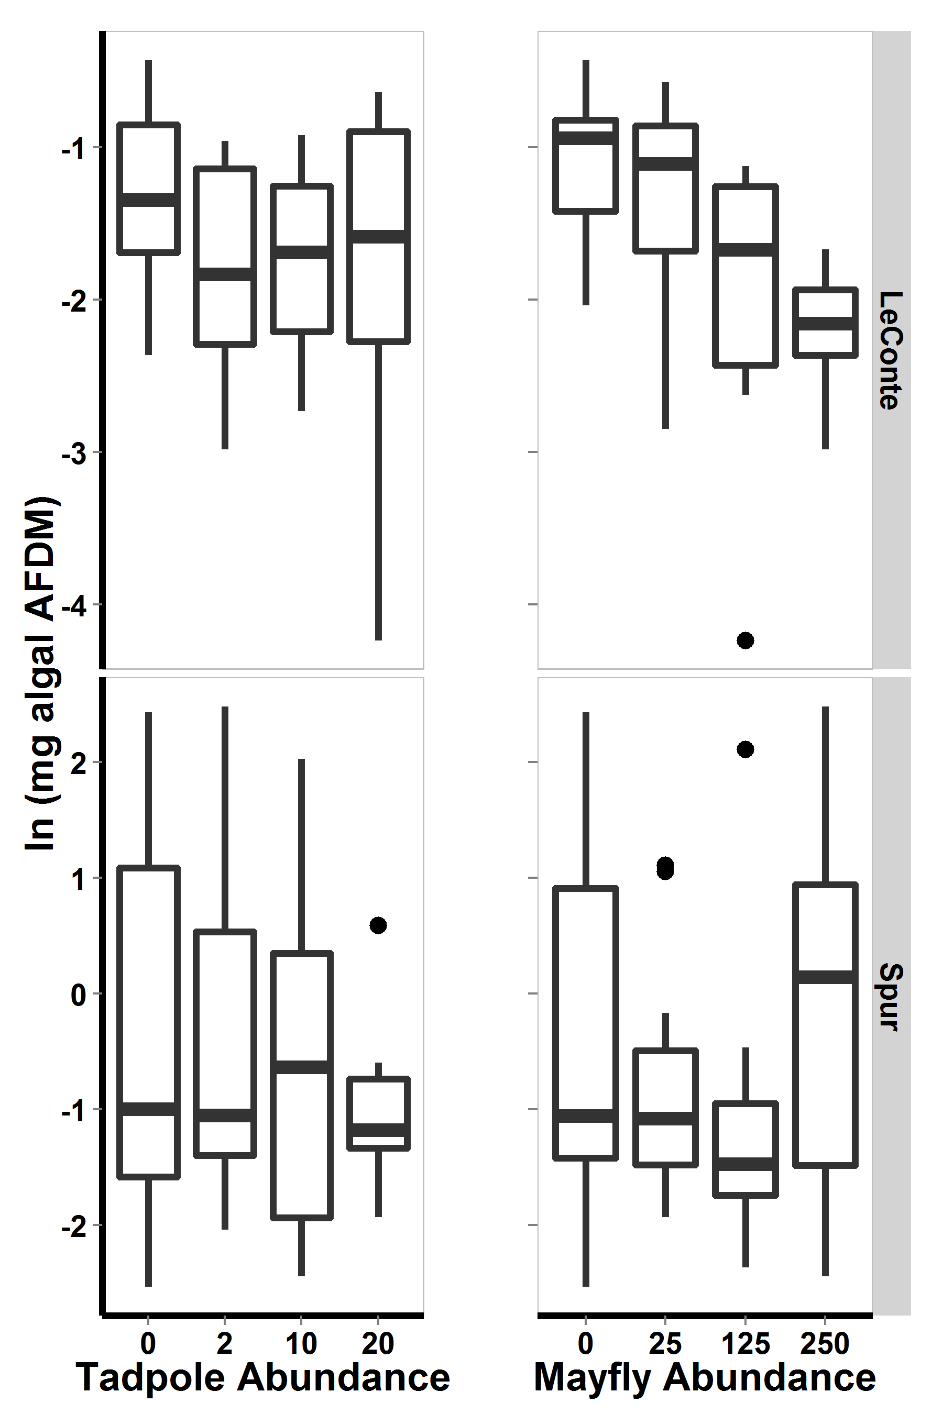

Figure 2. [Need to explain how calcualtions done. What were the replicates? For each consumer abundance, is this for each consumer density when alone or for each consumer density across all single and mixed species replicates? Are the replicates, the enclosure by 3 time periods for 3 datapoints from each enclosure? It would be much better to average each enclosure across time, so that you have one value for each enclosure. Can you conduct multiple comparisons tests to determine which treatments are different from each other?] Algal biomass versus tadpole (left) and mayfly(right) numbers per enclosure for LeConte Lake (top) and Spur Lake (bottom) in the 2009 lake enclosure experiment. In all boxplots, heavy bars show medians, boxes include 50% of the data, whiskers include 95% of the data, and dots lie outside the 95%.

Heat maps not useful or informative.

Heat maps not useful or informative. Only step away from raw data. Distill into basic trends or patterns using statistcs.

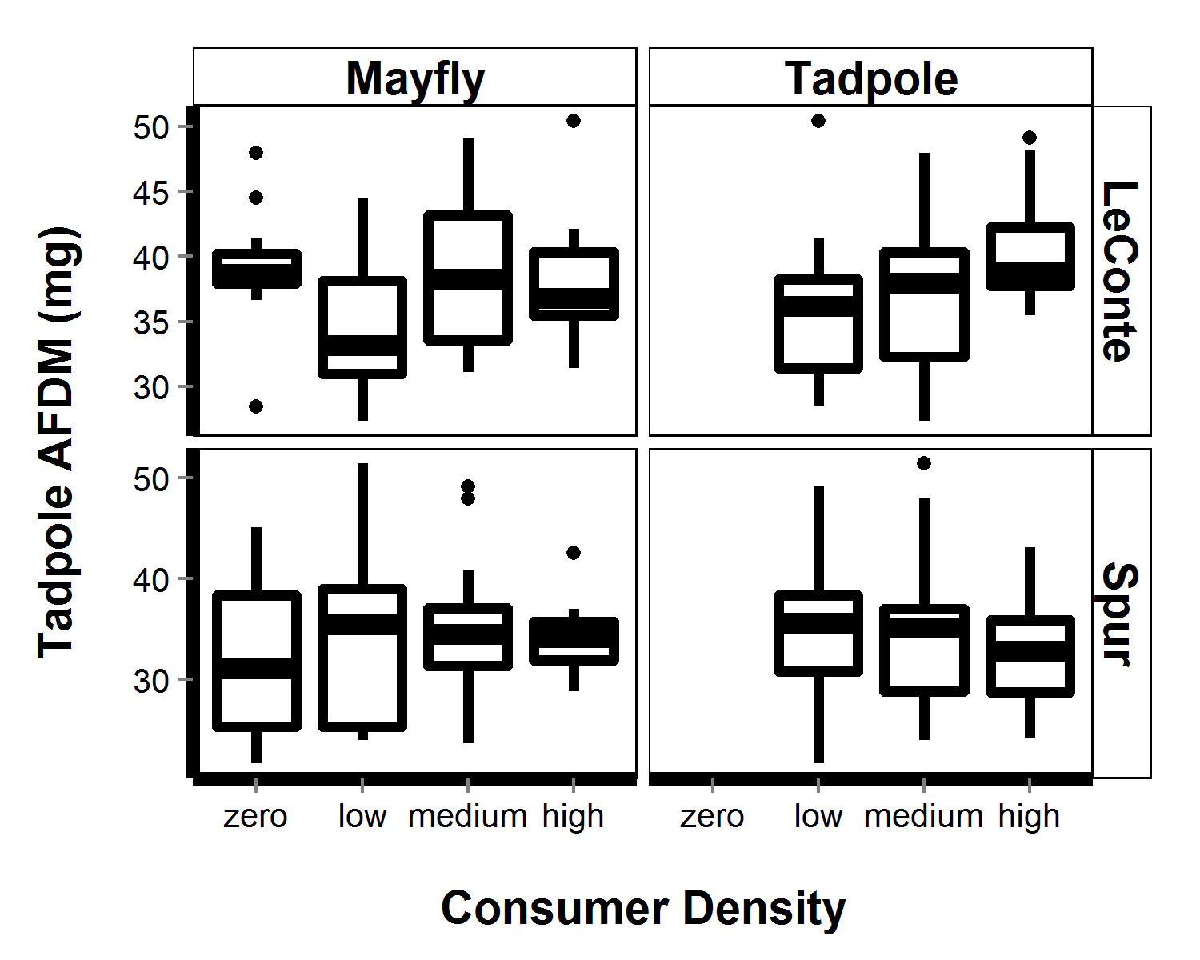

Figure 5. [Need to explain how calcualtions done. What were the replicates? For each consumer abundance, is this for each consumer density when alone or for each consumer density across all single and mixed species replicates? Are the replicates, the enclosure by 3 time periods for 3 datapoints from each enclosure? It would be much better to average each enclosure across time, so that you have one value for each enclosure. Can you conduct multiple comparisons tests to determine which treatments are different from each other? For clarity, the y-axis should be labeled average individual tadpole biomass and you could leabel the x-axis with mayfly density on the left and tadpole density on the right.] Average indivdiual tadpole AFDM (mg) versus mayfly (left) and tadpole (right) densities for LeConte Lake (top) and Spur Lake (bottom) in the 2009 lake enclosure experiment. In all boxplots, heavy bars show medians, boxes include 50% of the data, whiskers include 95% of the data, and dots lie outside the 95%.

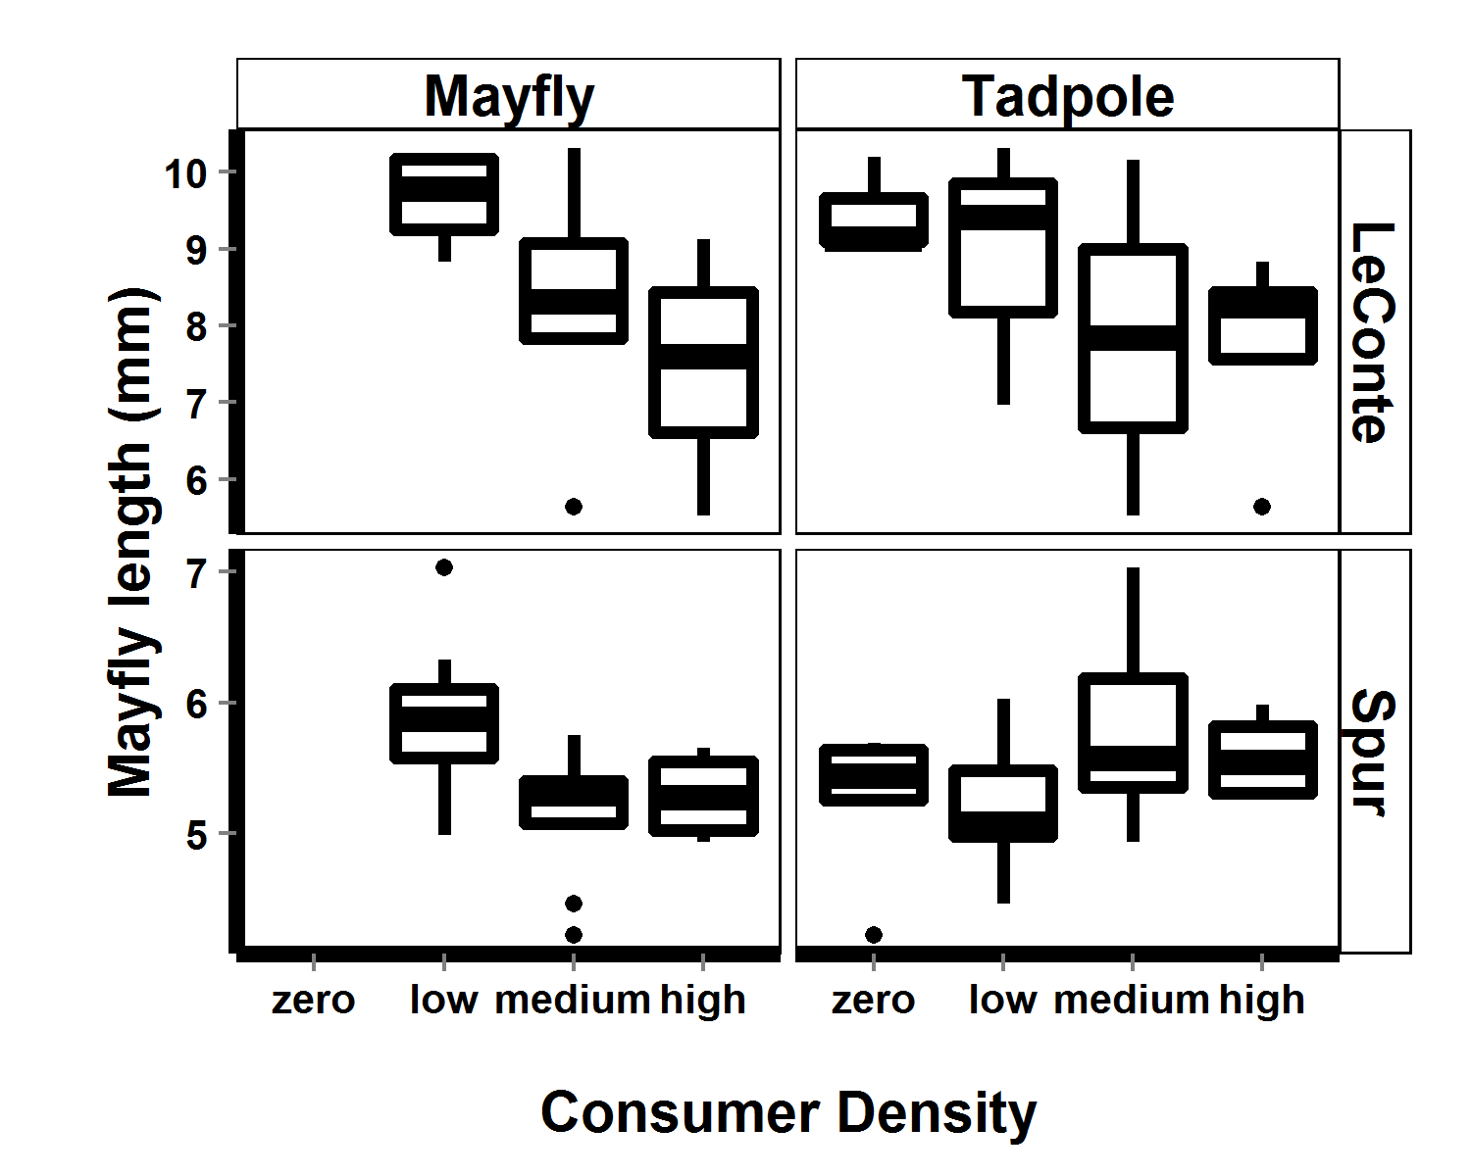

Figure 6. [Need to explain how calcualtions done. What were the replicates? For each consumer abundance, is this for each consumer density when alone or for each consumer density across all single and mixed species replicates? Are the replicates, the enclosure by 3 time periods for 3 datapoints from each enclosure? It would be much better to average each enclosure across time, so that you have one value for each enclosure. Can you conduct multiple comparisons tests to determine which treatments are different from each other?] Average mayfly length versus mayfly (left) and tadpole (right) densities for LeConte Lake (top) and Spur Lake (bottom) in the 2009 lake enclosure experiment. In all boxplots, heavy bars show medians, boxes include 50% of the data, whiskers include 95% of the data, and dots lie outside the 95%.

Note difference in mayfly length scales between lakes.

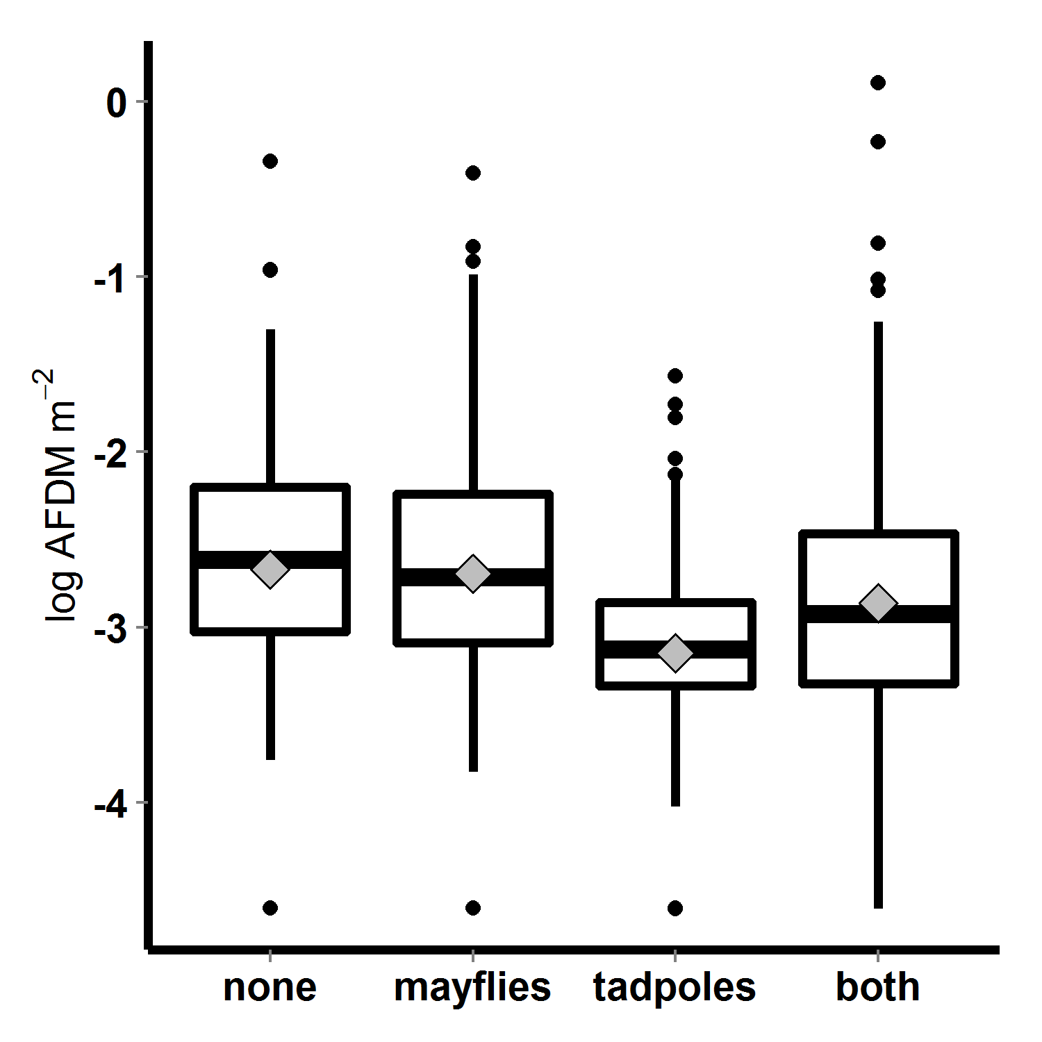(-0.11 + 0.08(-0.11 + 0.08

Figure 7. Algal biomass (log transformed AFDM m-2) across control (none) and consumer treatments (mayflies alone, tadpoles alone, both species together) in the 2010 mesocosm experiment. Bars indicate medians, boxes contain 50% of data, whiskers contain 95% of the data, points are outliers, and diamonds indicate means. [How were the statistics calculated? What are the replicates? If you have measurement across time, you should use just the final algal biomass or the algal biomass averaged for each tank across time. In either case, you end up with one value per tank and 4 values for each treatment. Those should be the replicates in calculations and analyses. This should all be clearly stated in the Methods. Do multiple comparisons tests to see which treatments are significantly different from each other.]

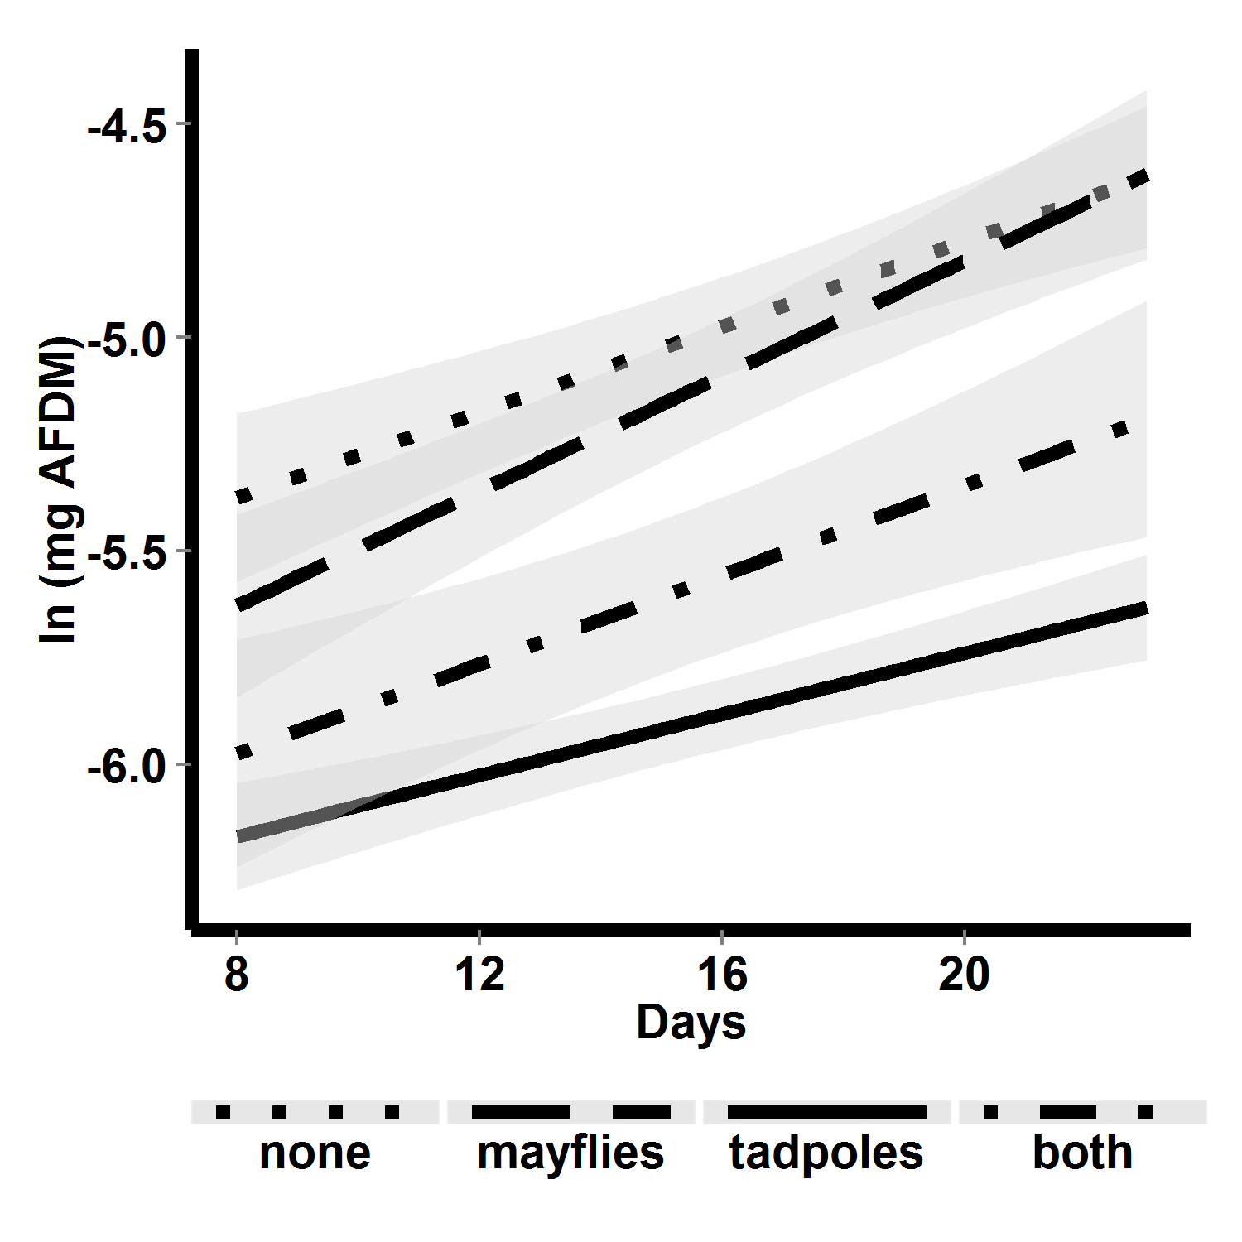

Figure 8. Algal biomass (loge AFDM m-2) over time in different control and consumer treatments in the 2010 mesocosm experiment. [Include the data, including the pre-data or 0 time data.] Lines are linear fits to temporal trends in algal biomasss, with shaded areas representing 95% confidence limits. [Should run analyses to determine if slopes and intercepts of different lines are significantly different. Although slopes don’t look different, intercepts certainly look different. Best analyzed as a 2-way repeated measures ANOVA or profile analysis. Certainly shows a tadpole effect, which can be distilled from Table 9.]

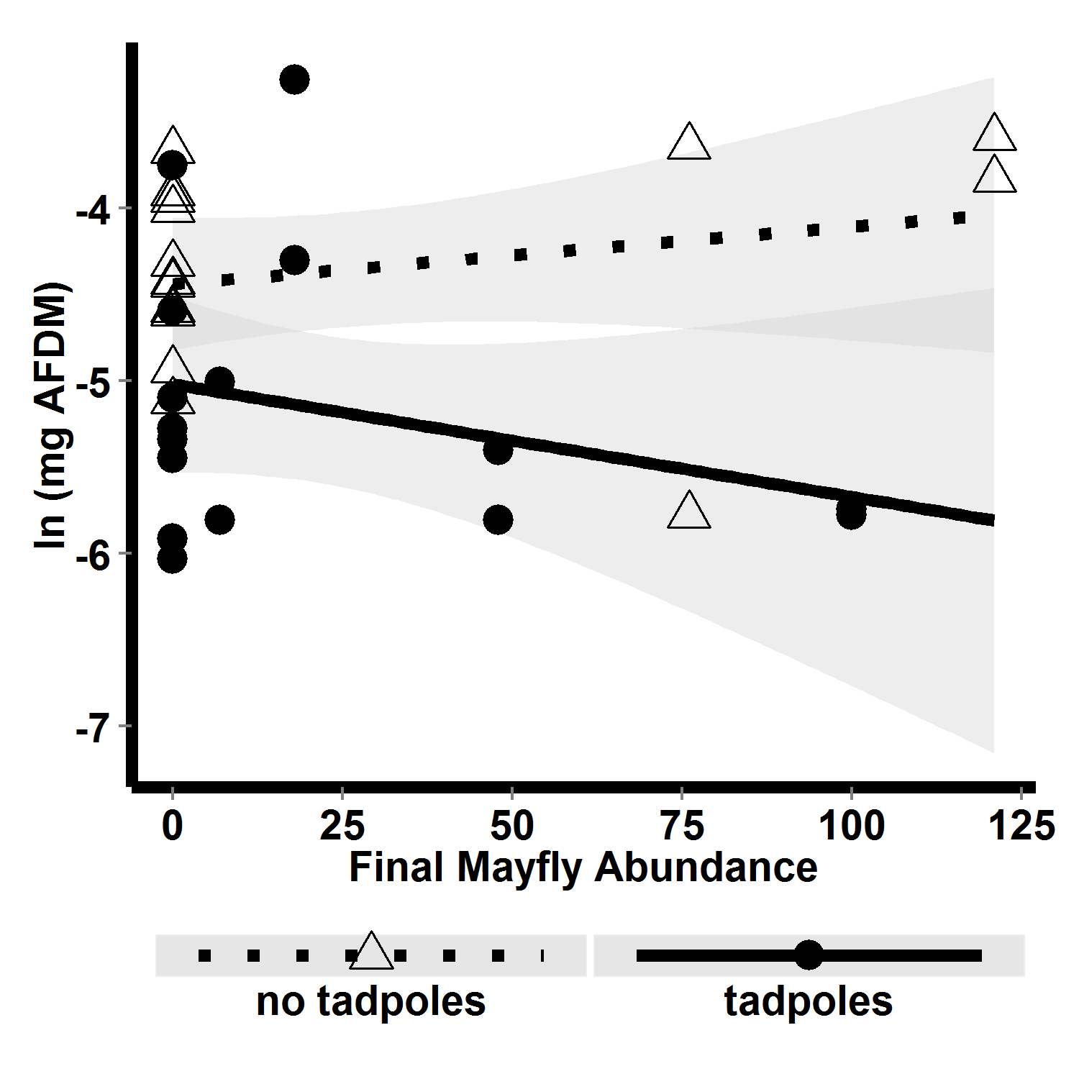

FIG. 9. Algal biomass versus final mayfly density for tanks containing (dots and solid line) and lacking (triangles and dotted line) tadpoles. [Distill results of Table 10 into this figure legend. Emphasize tadpole presence vs. mayfly density interaction effect, which is reflected in this graph. Include regression equation, R2, and p values for each line. Do analysis to compare slopes and intercepts for the two lines.]